AI ASSISTED CODING (ASSIGNMENT 9.1)
Lab Experiment: Documentation Generation – Automatic documentation and code
comments
Name : K. Chaithra
Roll No : 2503A52711
Batch No : 24

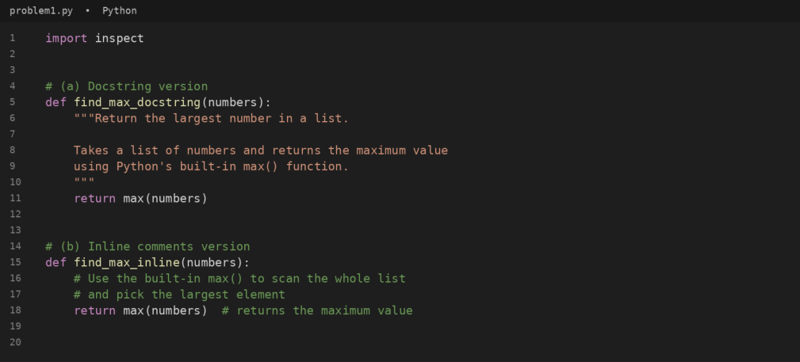

Q1:
Question:
Consider the following Python function:
def find_max(numbers):
return max(numbers)
Task: Write documentation for the function in all three formats: (a) Docstring (b) Inline comments (c) Google-style
documentation. Critically compare the three approaches. Discuss the advantages, disadvantages, and suitable use
cases of each style. Recommend which documentation style is most effective for a mathematical utilities library and
justify your answer.
Answer:
The Python program below documents find_max() in all three formats and takes the list of numbers from the user.
#code

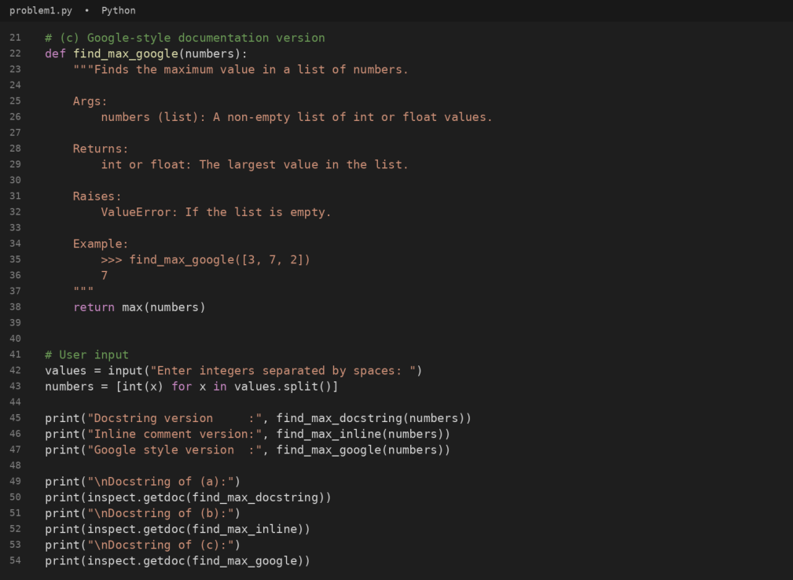

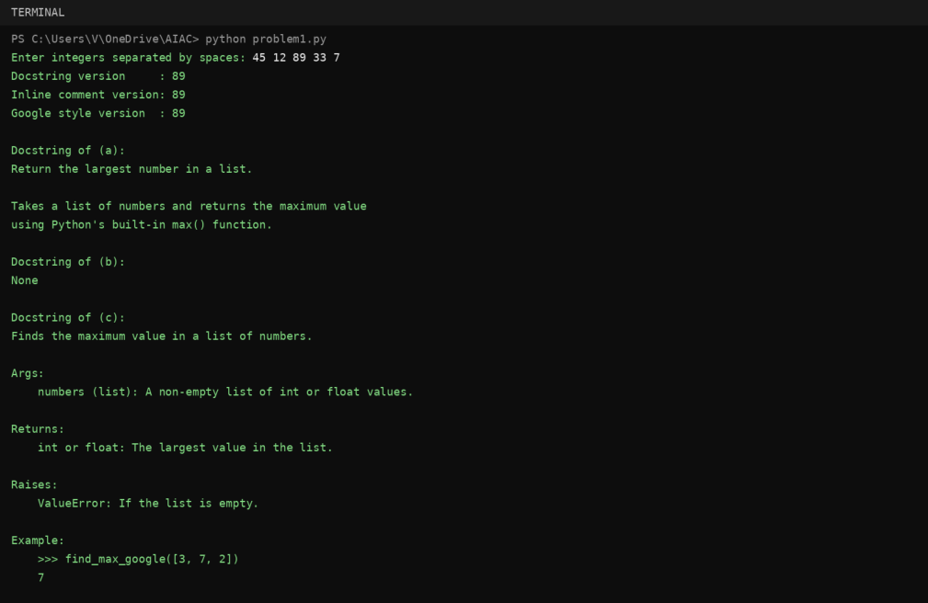

#output
#comparison of the three styles
Style | Advantages | Disadvantages | Suitable use cases
(a) Docstring | Stored with the function, so  help(), pydoc and IDE tooltips  can show it at run time. Short  and standard (PEP 257). | A plain summary has no fixed  structure, so parameter, return  and error details are easy to  leave out. | Small, simple functions that only need a short description.
(b) Inline  comments | Sit next to the exact line they  explain; good for explaining why  something is done. | Not available through help() or  documentation tools; easily  become outdated; a comment on a one-line max() call adds clutter. | Tricky or non-obvious logic  inside a function body, mainly for maintainers reading the source.
(c) Google-  style | Clear Args / Returns / Raises /  Example sections; easy to read  as plain text; Sphinx (napoleon)  and IDEs can parse it; examples  can run as doctests. | Longer than the code it describes for tiny functions; must be  updated whenever behaviour  changes. | Public APIs, libraries and team  projects where other people call  the function without reading its  code.
Recommendation: Google-style docstrings are the most effective for a mathematical utilities library. Mathematical
functions need precise contracts: the expected input types, what happens in edge cases (an empty list raises
ValueError), the return type and a worked example. The Args / Returns / Raises / Example sections capture all of this
in a fixed structure, the examples double as doctests, and tools such as help(), pydoc, IDE tooltips and Sphinx can
turn them into reference pages for the library's users. Inline comments should only supplement them where a line of
logic is not obvious.

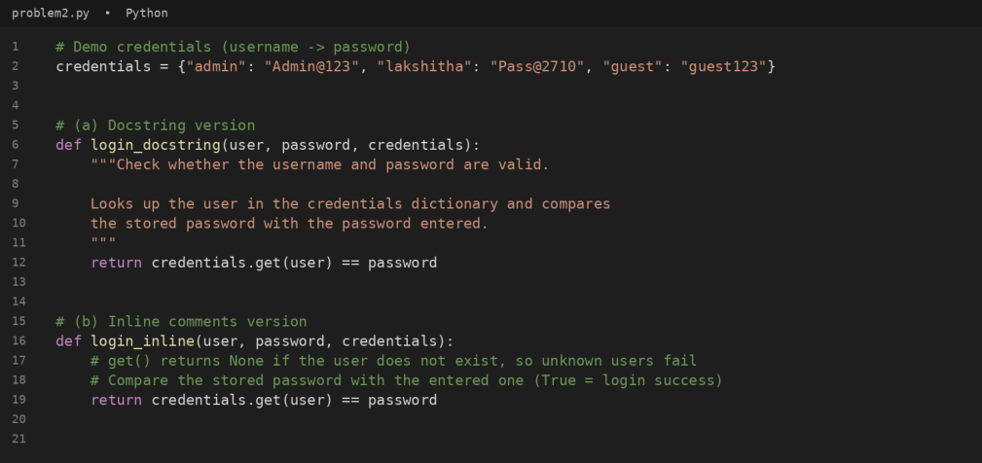

Q2:
Question:
Consider the following Python function:
def login(user, password, credentials):
return credentials.get(user) == password
Task: Write documentation in all three formats. Critically compare the approaches. Recommend which style would be
most helpful for new developers onboarding a project, and justify your choice.
Answer:
The Python program below documents login() in all three formats and takes the username and password from the
user.
#code

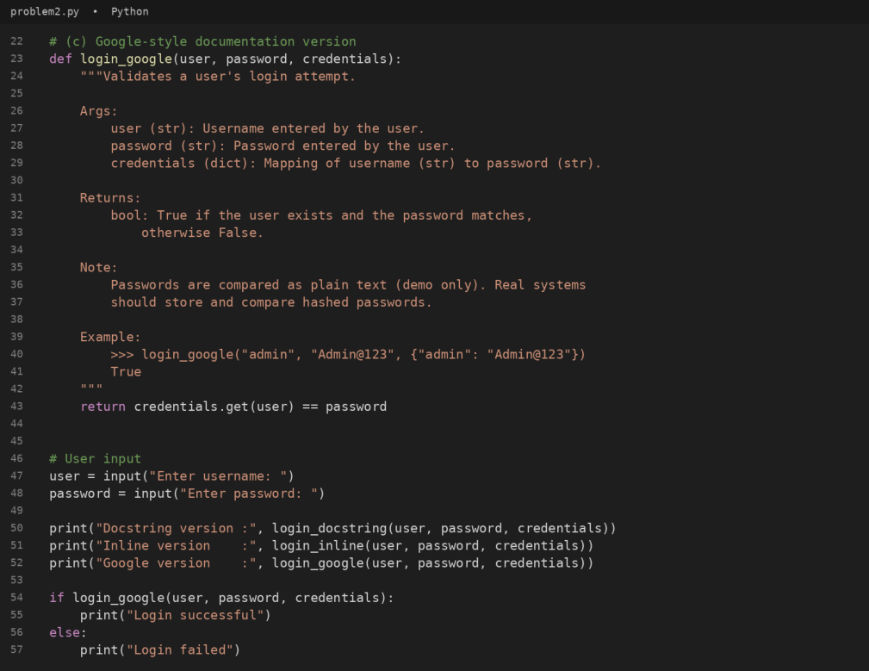
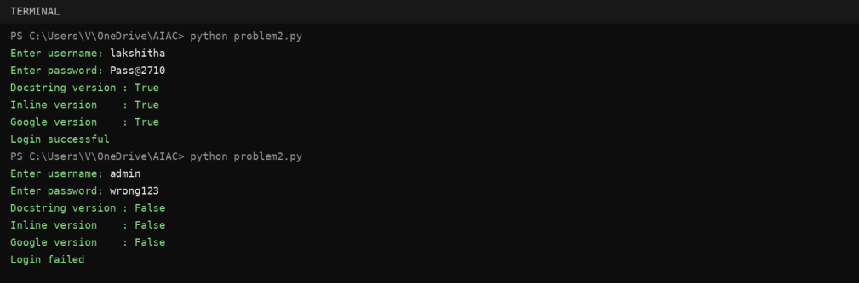

#output
#comparison of the three styles
Style | Advantages | Disadvantages | Suitable use cases
(a) Docstring | Explains the purpose of login() in help(login) with very little effort. | A short summary does not say  what shape credentials must  have or what is returned for an  unknown user unless the writer  adds it. | Quick description of small helper  functions.

Style | Advantages | Disadvantages | Suitable use cases
(b) Inline  comments | Explain details such as get()  returning None for unknown  users exactly where the logic  sits. | A newcomer only sees them after opening the source file; not  shown by help() or generated  documentation. | Clarifying tricky lines for people  already working inside the file.
(c) Google-  style | Args, Returns, Note and  Example tell a developer what to pass in (including the credentials dictionary format) and what to  expect, without reading the body. Same layout across the project. | Takes longer to write and must  be kept in sync with the code. | Shared or public functions in a  team codebase, especially for  onboarding.
Recommendation: Google-style docstrings are the most helpful for new developers onboarding a project. A
newcomer can call login() correctly just by reading its docstring: it shows the type of every argument, the structure of
the credentials dictionary, that the result is a bool (False for an unknown user), a runnable example and a security
note about plain-text passwords. The same text appears in help(), IDE tooltips and generated HTML documentation,
so nobody has to open the source. Inline comments are a good supplement for one specific line, but they are
invisible to documentation tools.

Q3:
Question:
Task: Design a Python module named calculator.py and demonstrate automatic documentation generation.
Instructions: Create a Python module calculator.py that includes the following functions, each written with appropriate
docstrings:
add(a, b) – returns the sum of two numbers
subtract(a, b) – returns the difference of two numbers
multiply(a, b) – returns the product of two numbers
divide(a, b) – returns the quotient of two numbers
Display the module documentation in the terminal using Python’s documentation tools. Generate and export the
module documentation in HTML format using the pydoc utility, and open the generated HTML file in a web browser to
verify the output.
Answer:
The module calculator.py below contains add(), subtract(), multiply() and divide(), each with a docstring. A main block
takes the numbers and the operation from the user when the file is run directly.
#code

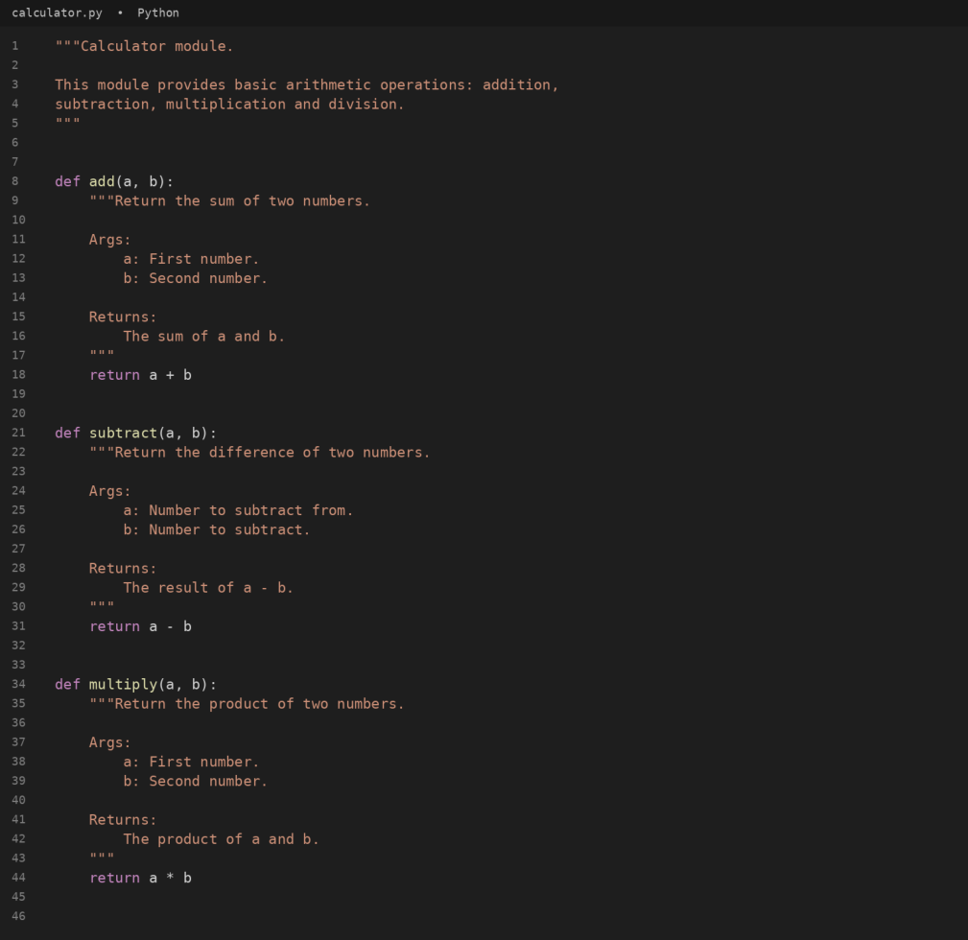

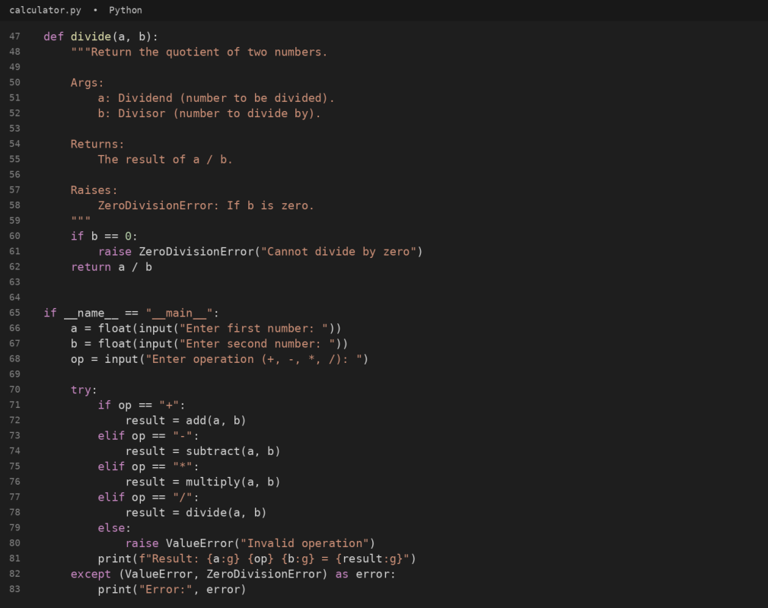
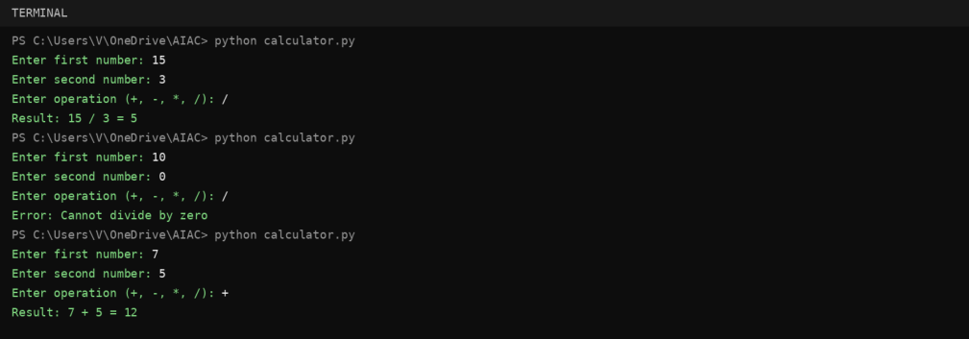

#output

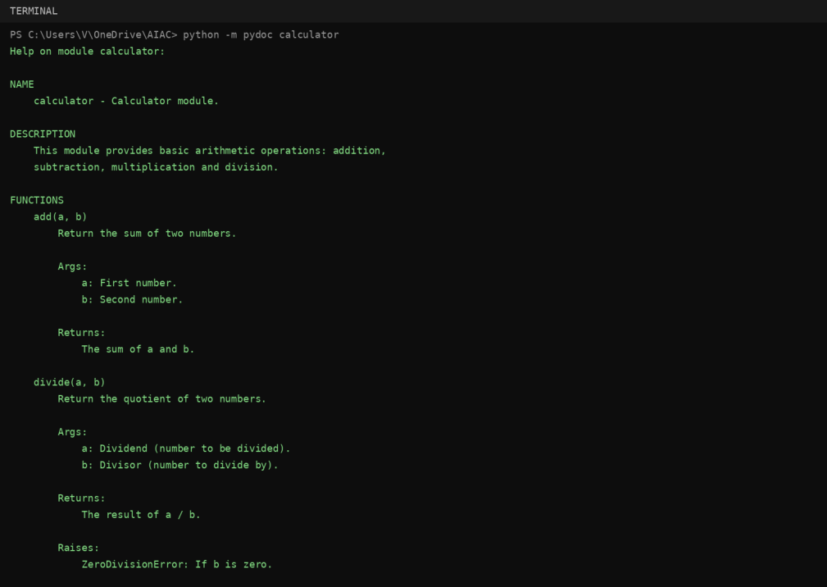
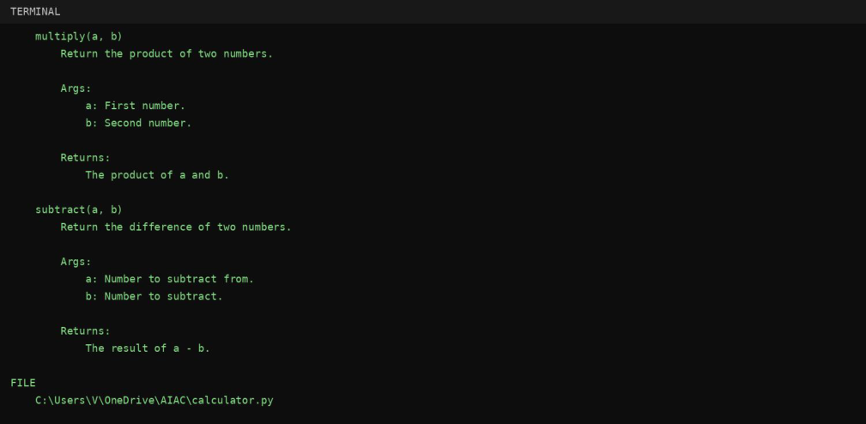

#documentation in the terminal (python -m pydoc calculator)

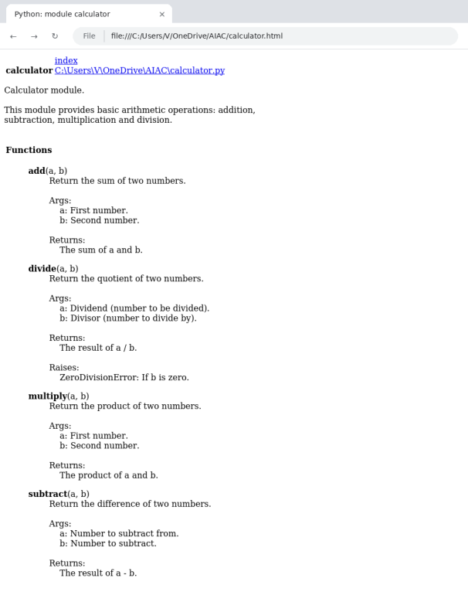

#export documentation as HTML (python -m pydoc -w calculator)
#calculator.html opened in a web browser

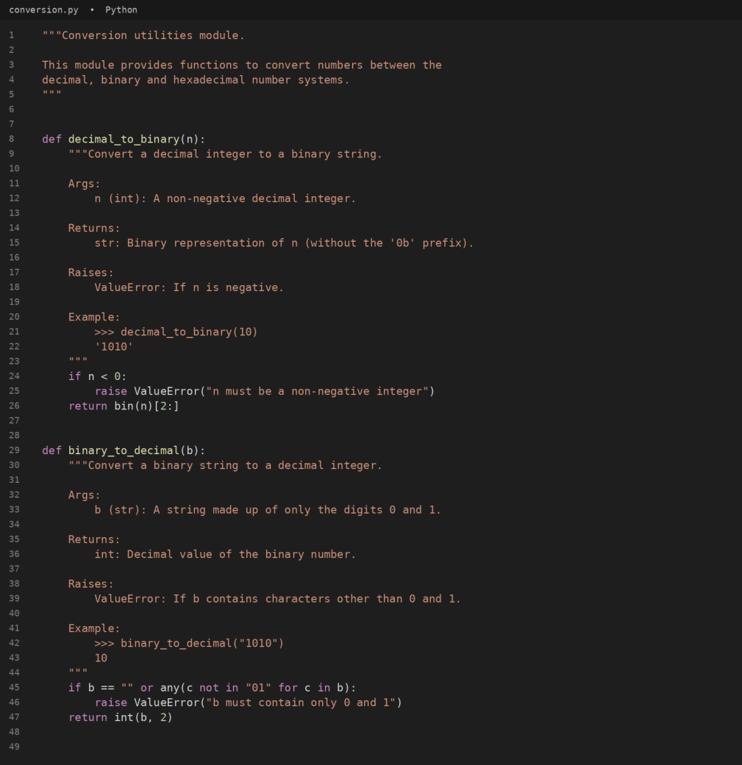
Q4:
Question:
Task: Write a module named conversion.py with functions: decimal_to_binary(n), binary_to_decimal(b),
decimal_to_hexadecimal(n).
Use Copilot for auto-generating docstrings. Generate documentation in the terminal. Export the documentation in
HTML format and open it in a browser.
Answer:
The module conversion.py below contains the three conversion functions, each with a docstring. A main block asks
the user which conversion to perform and reads the number to convert.
#code

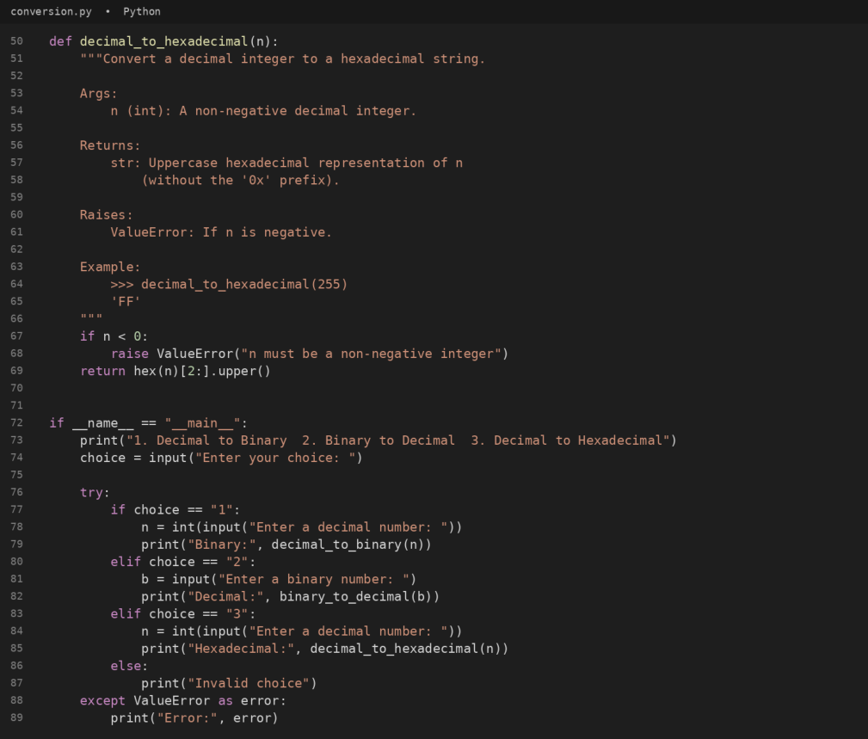
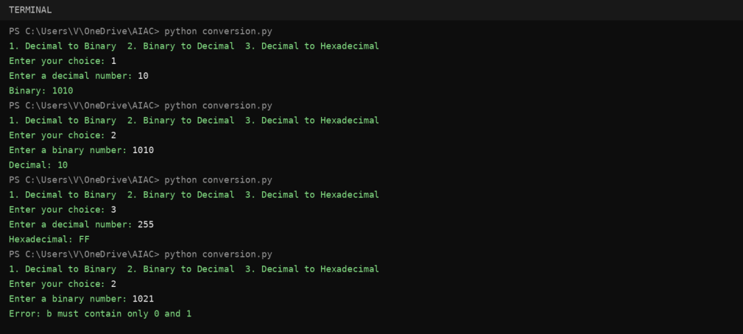

#output

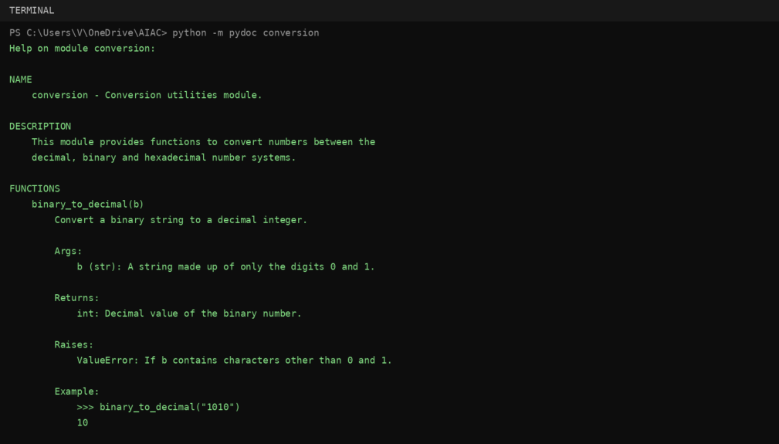
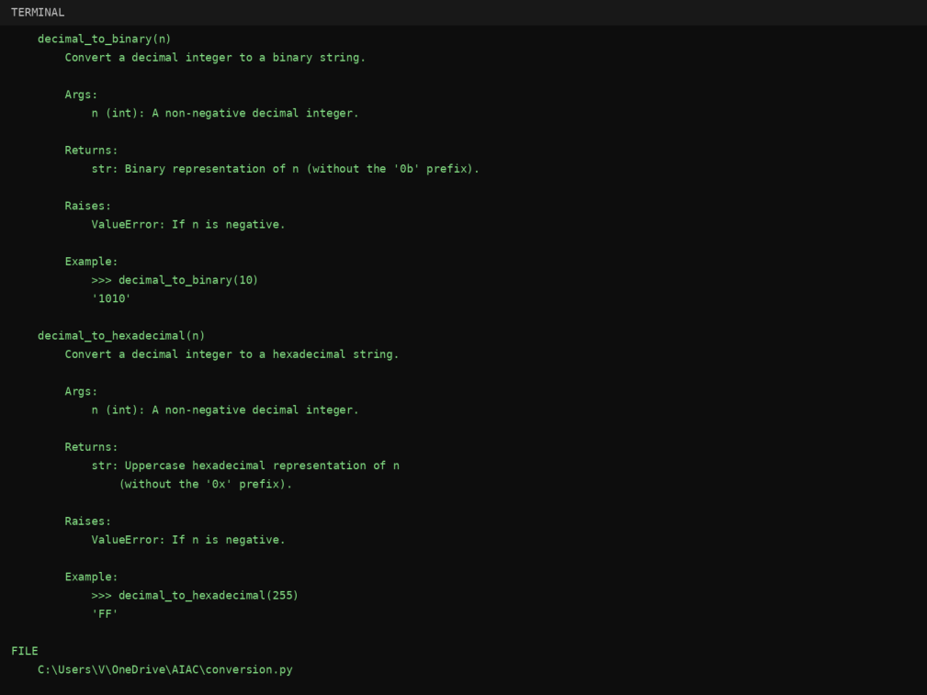

#documentation in the terminal (python -m pydoc conversion)

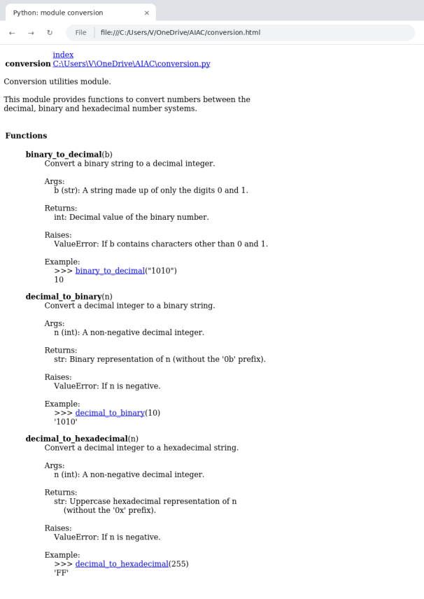

#export documentation as HTML (python -m pydoc -w conversion)
#conversion.html opened in a web browser
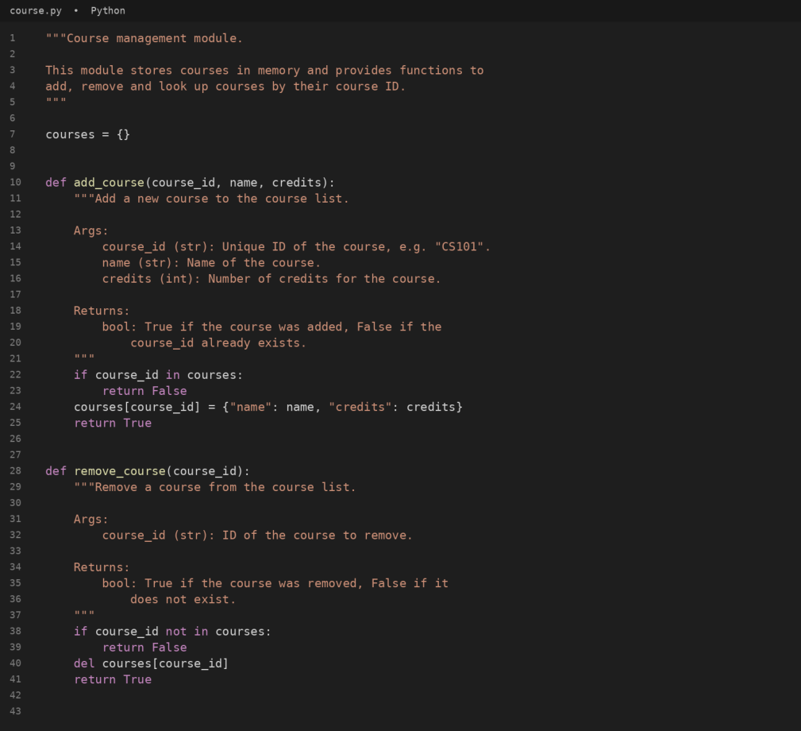
Q5:
Question:
Task: Create a module course.py with functions: add_course(course_id, name, credits), remove_course(course_id),
get_course(course_id).
Add docstrings with Copilot. Generate documentation in the terminal. Export the documentation in HTML format and
open it in a browser.
Answer:
The module course.py below stores courses in memory and provides add_course(), remove_course() and
get_course(), each with a docstring. A menu-driven main block takes the course details from the user.
#code

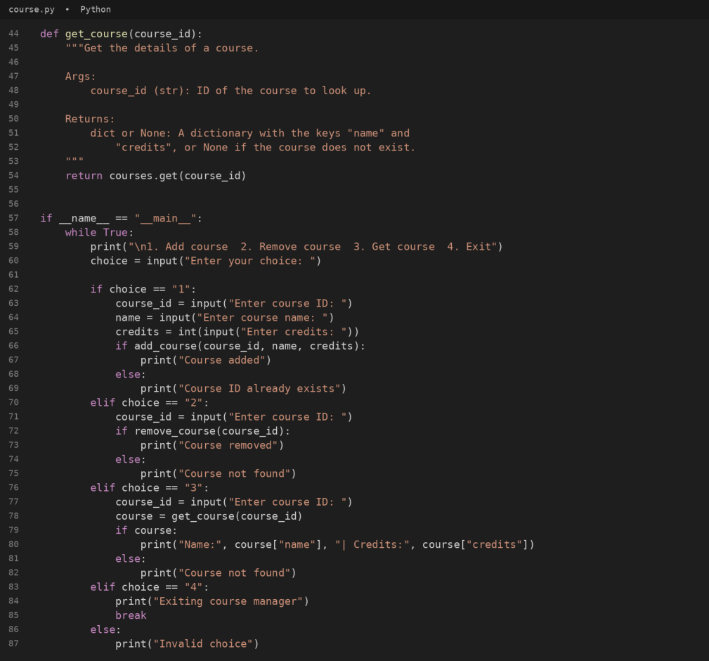

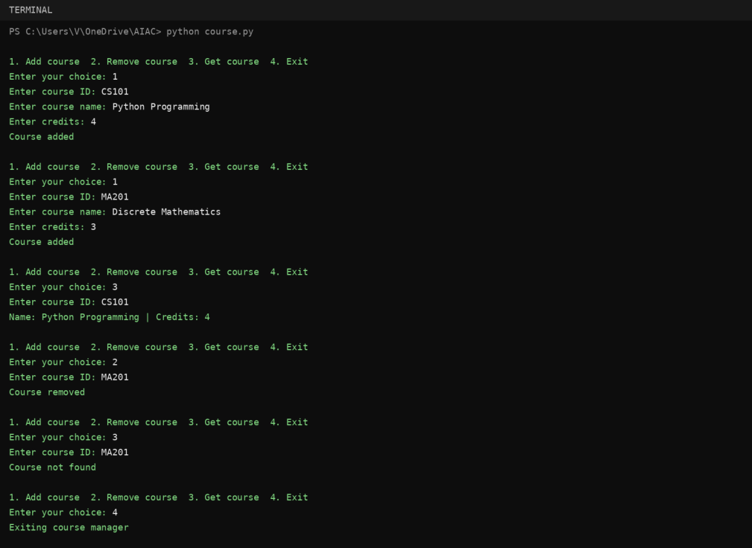
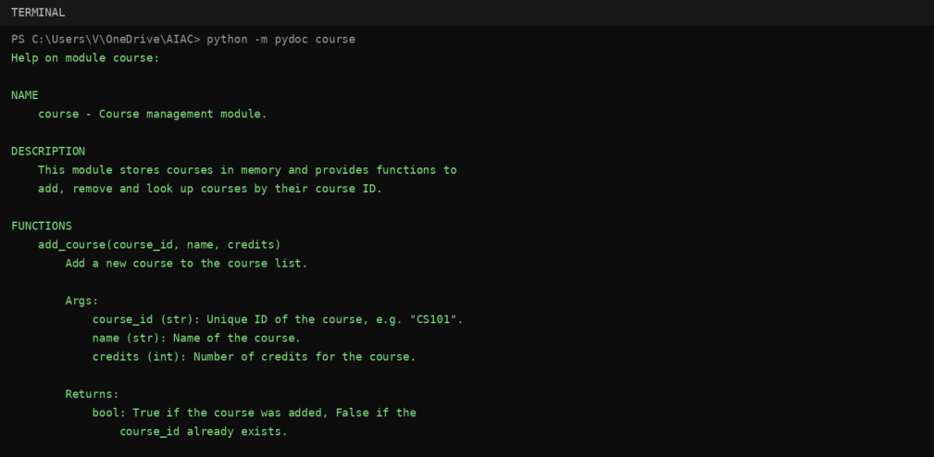

#output
#documentation in the terminal (python -m pydoc course)

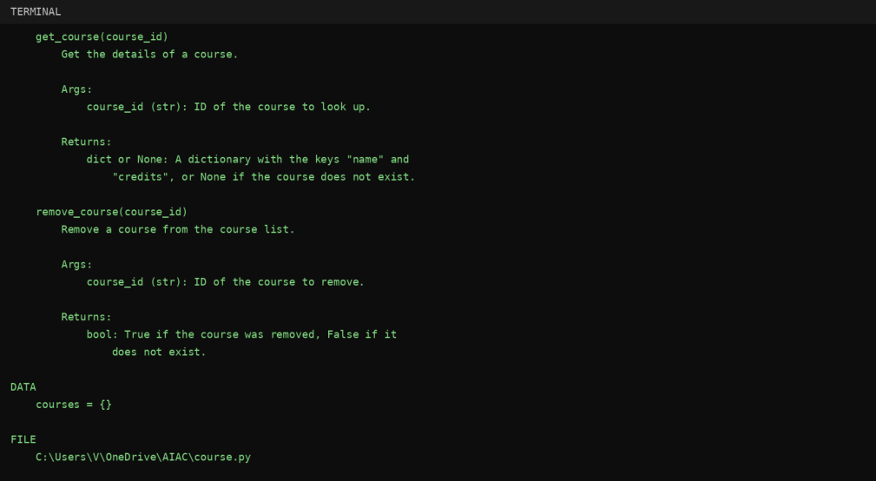

#export documentation as HTML (python -m pydoc -w course)

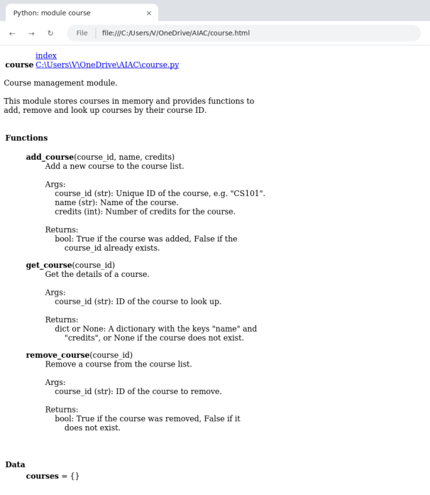

#course.html opened in a web browser

CONCLUSION:
All five problems were completed. find_max() and login() were documented using docstrings, inline comments and
Google-style documentation and the styles were compared. The modules calculator.py, conversion.py and course.py
were documented with docstrings, viewed in the terminal with pydoc, exported as HTML pages with pydoc -w and
verified in a web browser, as required in Lab 9.1.

